Program 7: Configuration Management with Ansible: Basics of Ansible – Inventory, Playbooks, and Modules. Automating server configurations with playbooks. Hands-on: Writing and running a basic Ansible playbook.

Step 1: Install Ubuntu (from Microsoft Store)
- Open Microsoft Store
- Search → Ubuntu
- Install (e.g., Ubuntu 22.04)
- Open it and create: p
  - Username
  - Password

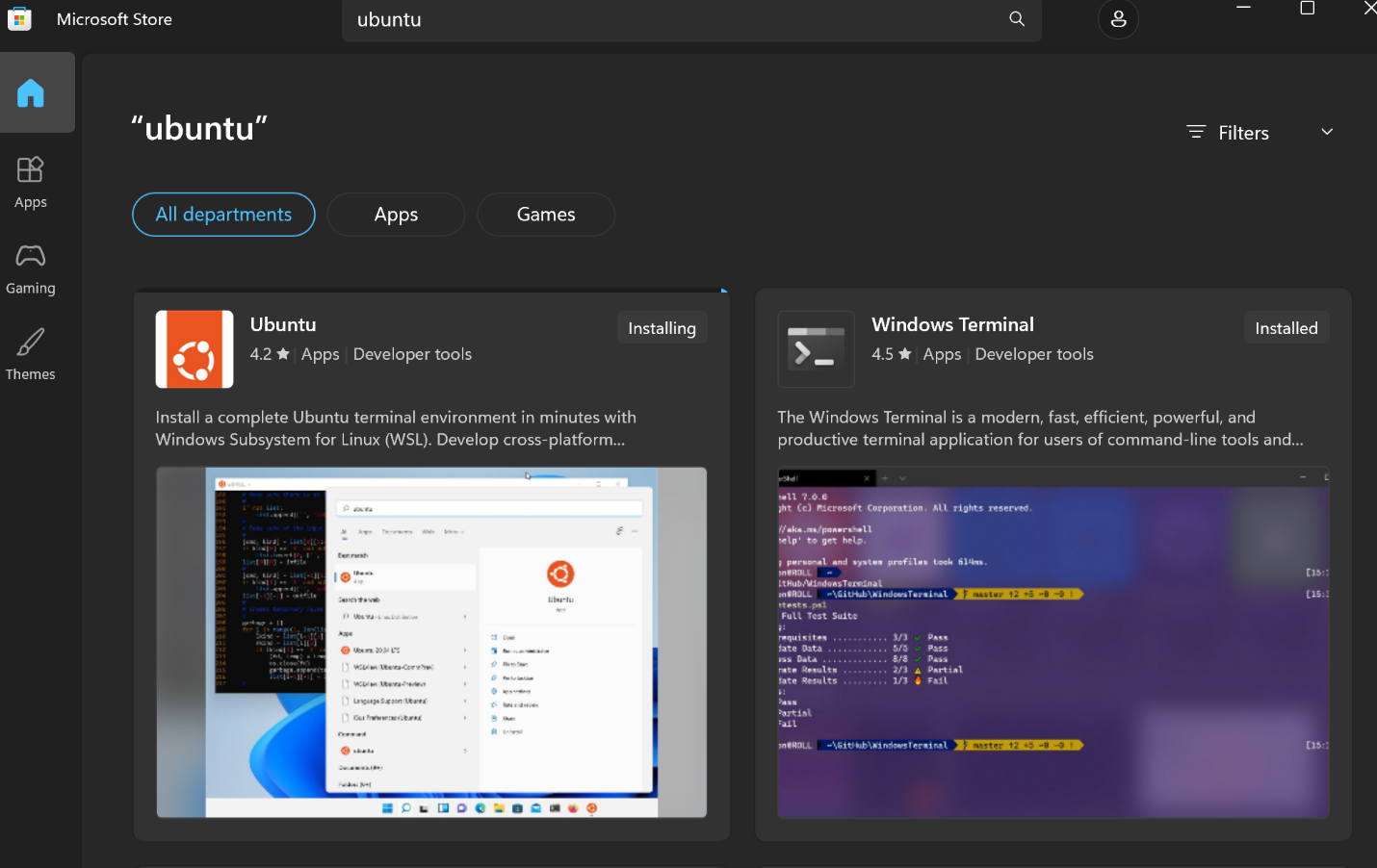

Step 2: Open PowerShell as Administrator (This step should be executed during the first-time installation)
- Click Start lok
- Search → PowerShell
- Right click → Run as Administrator.
Run this command: wsl –install

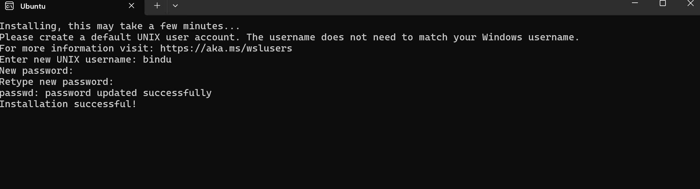

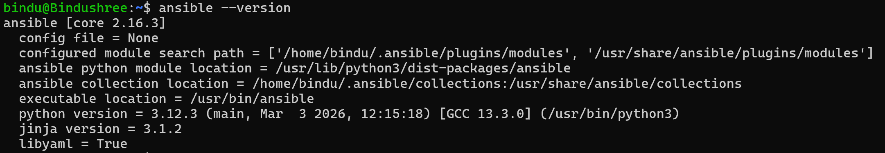


Inside inventory add this:
localhost ansible_connection=local
Save:
- Press CTRL + X
- Press Y
- Press Enter

Test Connection: ansible all -i inventory -m ping
Create Playbook:
nano playbook.yml
and add this code:
- name: Install Apache using Ansible
hosts: all
become: yes

tasks:
- name: Install apache2
apt:
name: apache2
state: present

- name: Start apache2 service
service:
name: apache2
state: started

Run Playbook: ansible-playbook -i inventory playbook.yml
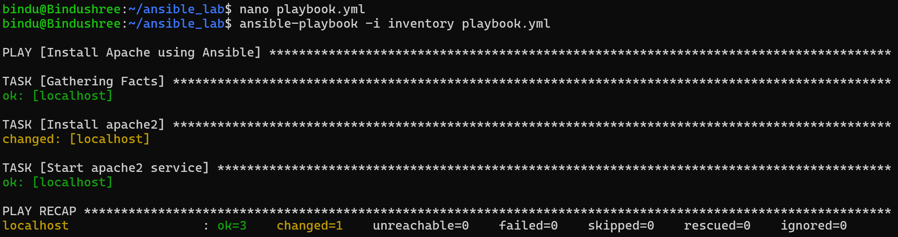

Verify Output
Check Apache status: systemctl status apache2
And open browser: http://localhost:80
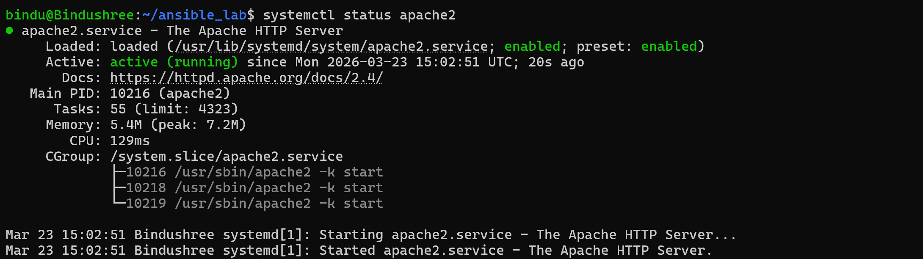
sudo systemctl stop apache2
A playbook is a file where you write automation steps.
- Written in YAML
- Contains tasks to perform

YAML is a simple format used to write playbooks, Language used to write playbook. YAML stands for YAML Ain’t Markup Language, used to write configuration files in a simple readable format.

A module is a ready-made function in Ansible
Examples:
- apt → install packages
- ping → test connection
- copy → copy files
A task is a single action
Example: - name: Install apache
apt:
name: apache2
state: present

systemctl is a Linux command to control services

sudo means run as admin (root user)
APT (Advanced Package Tool) is used in Ubuntu/Linux to:
- Install software
- Update software
- Remove software
SSH stands for Secure Shell, used for secure remote login and command execution.

